**Task 2**

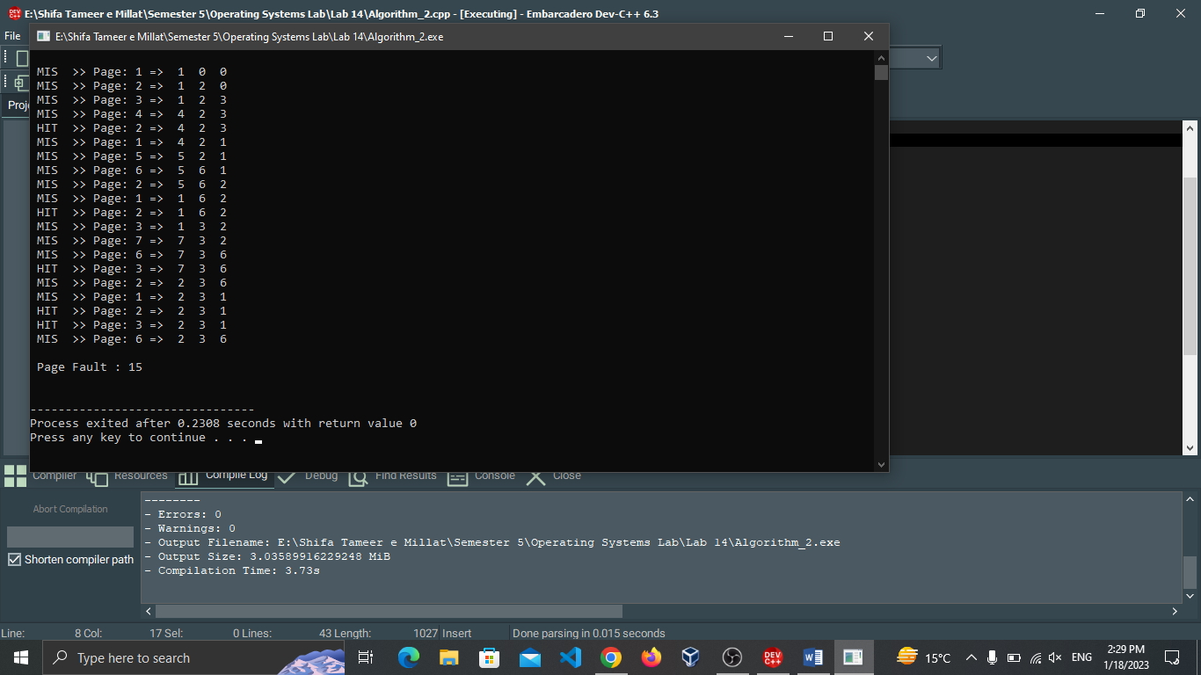

This is an implementation of the Least Recently Used (LRU) page replacement algorithm. The algorithm uses a doubly linked list to keep track of the pages in memory and their order of usage. When a page is accessed, it is moved to the back of the list, and when a page fault occurs, the page at the front of the list (the least recently used page) is replaced with the new page.

We have 15 misses and 5 hits in the output. We run this program on 3 frames and with 20 pages at start.